Bridges of Washington County GTA Rally

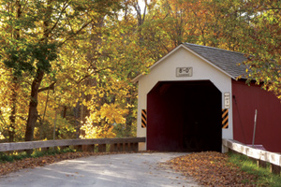

A family‐friendly, fun road rally presented by MoHud SCCA

Saturday, October 19, 2013

Departure from: Latham Farms – Sam’s Club Parking Lot
Registration & Safety Inspection: 10:00am-10:45am
Participant’s Meeting: 10:45am
First car off: 11:00am

Entry Fee: $15/car

The Bridges of Washington County Rally is a straight‐forward rally (no traps or tricks) using an instruction format. There will be an observation component to this rally. The route spends some time on unpaved roads, but none that are “car‐breakers”. The rally should take less than 3 hours to complete. It will run in any weather. This rally is intended to be for entertainment only – bring the kids along to share in the fun. There will be an awards ceremony immediately following the rally, which will end at a restaurant; we hope you all stay for a bite to eat and some socializing.

If you have any questions, contact Trish Bucci, Rallymaster, at trimar71@gmail.com or 728‐8943

